The Lakes at University Center

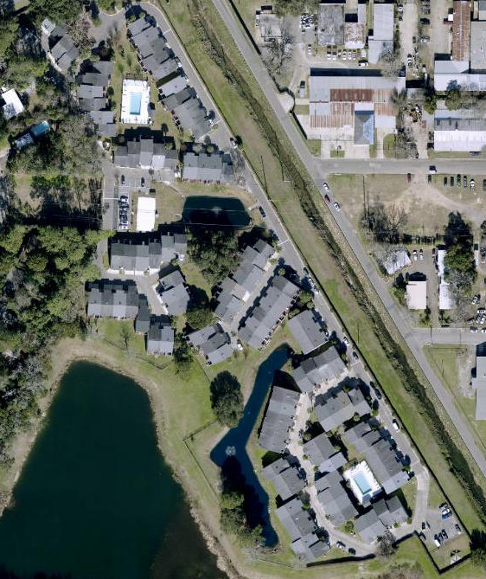

Key

Trash Can Bulk

Dumpster Recycling

Dog Station

